**A CRM APPLICATION OF SCHOOL / COLLEGE**

**PROJECT REPORT TEMPLATE**

**1. INTRODUCTION**

**1.1 Overview**

The project aim is to provide real-time knowledge for all the students who have basic knowledge of Salesforce and looking for a real-time project thought .This project will also help those professionals who are in cross-technology and went to switch to Salesforce . With the help of this project they will gain knowledge and can include it into their resume as well.

**1.2 Purpose**

The use of this project is it helps us to maintain and manage the school related problems which further can be modified based on the requirements.

The achievement using this project , Real Time Salesforce Project ; Object & Relationship in Salesforce ; Profile Users Reports Permission sets ; Reports .

**2. PROBLEM DEFINITION AND DESIGN THINKING**

**2.1 Empathy Map**

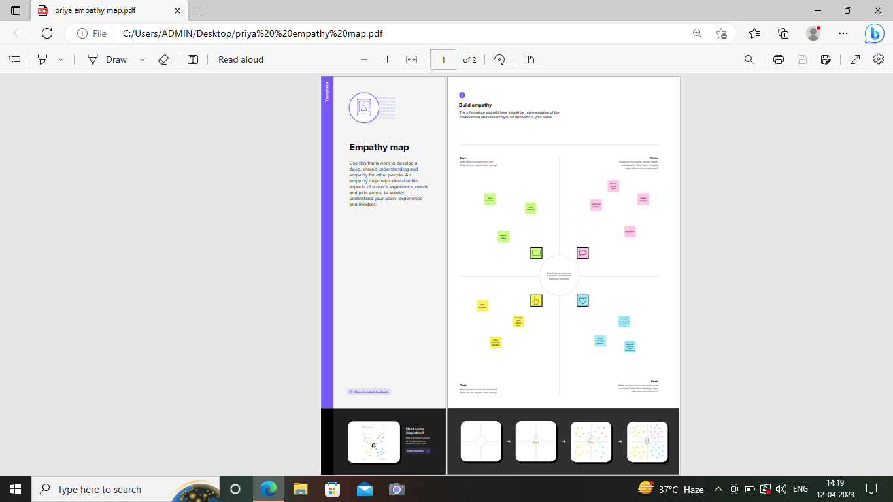

**2.2 Idea & Brainstorming map**

|  |
| --- |
| Screenshot (7).png |

**3. RESULT**

**3.1 Data model:**

|  |  |
| --- | --- |
| **Object name** | **Fields in the Object** |
| School | |  |  | | --- | --- | | **Field label** | **Data type** | | Address | Text Area | | District | Text Area | | State | Text Area | | School websites | Text Area | |
| Student | |  |  |  |  |  |  |  |  |  |  |  |  |  | | --- | --- | --- | --- | --- | --- | --- | --- | --- | --- | --- | --- | --- | | |  |  | | --- | --- | | **Field label** | **Data type** | | Phone number | Phone | | School | Master detail relation | | Result | Picklist | | Class | Number | | Marks | Number | | |
| Parent | |  |  | | --- | --- | | **Field label** | **Data type** | | Parent Address | Text Area | | Parent Number | Phone | |

**3.2 Activity & Screenshot**

Milestone-1: Account activated

|  |
| --- |
| Screenshot (9).png |

Milestone-2: Object

|  |
| --- |
| Screenshot (10).png |

Milestone-3: Lightening App

|  |
| --- |
| Screenshot (11).png |

App Name: School Management

|  |
| --- |
| Screenshot (12).png |

Milestone-4: Fields and Relationship ( fields for school object, student object ,parents object)

|  |
| --- |
| Screenshot (13).png |

|  |
| --- |
| Screenshot (14).png |

|  |
| --- |
| Screenshot (15).png |

|  |
| --- |
| Screenshot (16).png |

|  |
| --- |
| Screenshot (17).png |

|  |
| --- |
| Screenshot (18).png |

|  |
| --- |
| Screenshot (19).png |

Milestone-5: Profile

|  |
| --- |
| Screenshot (20).png |

|  |
| --- |
| Screenshot (21).png |

Milestone-6: Users

|  |
| --- |
| Screenshot (22).png |

Milestone-7: Permission sets

|  |
| --- |
| Screenshot (23).png |

|  |
| --- |
| Screenshot (24).png |

Milestone-8: Report

|  |
| --- |
| Screenshot (26).png |

**4. Trailhead Profile Public URL**

TEAM LEADER - https://trailblazer.me/id/priyaanan35

TEAM MEMBER 1 – https://trailblazer.me/id/ssandy122

TEAM MEMBER 2 - https://trailblazer.me/id/yasov2

TEAM MEMBER 3 – https://trailblazer.me/id/mphysicsca

**5 ADVANTAGES & DISADVANTAGE**

**ADVANTAGES**:

1. UNIFIED VIEW OF THE CONSTITUENTS

2. CONNECTED EXPERIENCE

3. SIMPLIFIED STUDENT RECRUITMENT

4. SUPPORT STUDENTS

5. 1:1 CUSTOMIZED STUDENT EXPERIENCE

**DISADVANTAGES:**

1. EXPENSIVE

2. CONFIGURATION AND SETUP IS COMPLEX AND TIME CONSUMING

3. MENTOR SUPPORT DURING PROJECT TIME HAS VERY POOR

4. THE LEARNING CURVE SEEMS TO BE NEVER END

**6 APPLICATIONS**

THIS SALESFORCE CRM APPLICATION OF SCHOOL /COLLEGE IS FOR THE PURPOSE OF SCHOOL / COLLEGE TO MAITAIN RELETIONSHIP BETWEEN SCHOOL MANAGEMENT , STUDENTS , PARENTS .

**7 CONCLUSION**

A CRM SYSTEM HELPS YOU KEEP YOUR CUSTOMERS CONTACT DETAILS UP TO DATE , TRACK EVERY INTERACTION THEY HAVE WITH TYOUR BUSINESS , AND MANAGE THEIR ACCOUNTS.

**8 FUTURE SCOPE**

THE RIGHT SALESFORCE TRAINING PROPS US AHEAD IN A NICHE AREA WHERE THE SCOPE FOR CAREER GROWTH AND SALARY IS SKY – HIGH.